**Project Design Phase-II**

**Data Flow Diagram & User Stories**

|  |  |
| --- | --- |
| Date | 5 April 2025 |
| Team ID | SWTID1743696165 |
| Project Name | Bookie Nest: Book management website |
| Maximum Marks | 4 Marks |

**Data Flow Diagrams:**

A Data Flow Diagram (DFD) for **Bookie Nest** is a graphical tool used to represent the flow of data within the online book store system. It visually illustrates how data moves from user input—such as browsing books or placing orders—to various processes like search, cart management, and payment handling. It also shows interactions with external entities such as users and administrators, as well as internal storage areas like book inventory and order records. The DFD helps in understanding how information is processed within **Bookie Nest**, from user actions to database updates and administrative tasks. This makes it an essential tool during the planning and analysis phase, offering stakeholders a simplified yet comprehensive view of the platform’s functionality and data interactions.

**Example:**

**Level-0 DFD:**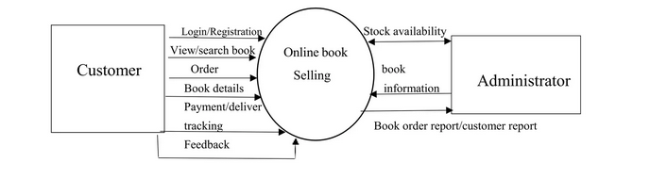

**Level -1 DFD:**

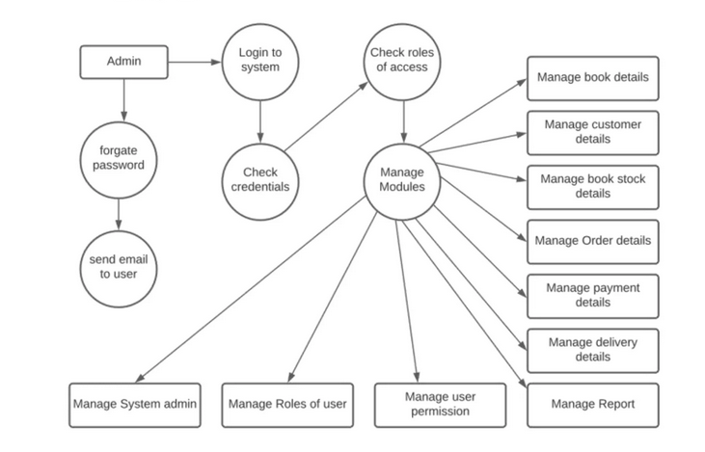

**User Stories**

Use the below template to list all the user stories for the product.

| **User Type** | **Functional Requirement (Epic)** | **User Story Number** | **User Story / Task** | **Acceptance criteria** | **Priority** | **Release** |
| --- | --- | --- | --- | --- | --- | --- |
| Customer (Mobile user) | Registration | USN-1 | As a user, I can register for the application by entering my email, password, and confirming my password. | I can access my account / dashboard | High | Sprint-1 |
|  |  | USN-2 | As a user, I will receive confirmation email once I have registered for the application | I can receive confirmation email & click confirm | High | Sprint-1 |
|  |  | USN-3 | As a user, I can register for the application through Google | I can register & access the dashboard with Facebook Login | Low | Sprint-2 |
|  |  | USN-4 | As a user, I can register for the application through Gmail | I can register & access the dashboard with Gmail Login | Medium | Sprint-1 |
|  | Login | USN-5 | As a user, I can log into the application by entering email & password | I can access the dashboard | High | Sprint-1 |
|  | Dashboard | USN-6 | As a user, I can view upcoming Books, location, and timings | I can see and select book based on filters | High | Sprint-2 |
| Customer (Web user) | Purchase | USN-7 | As a user, I can select Books and buy it | I receive purchase confirmation | High | Sprint-2 |
|  | Payment | USN-8 | As a user, I can pay via UPI/Credit Card/Net Banking | Payment goes through and receipt is generated | High | Sprint-3 |
| Customer Care Executive | Purchase Support | USN-9 | As an executive, I can view and help with customer Purchase and Return | I can search, view, and update Book in my cart | Medium | Sprint-3 |
| Administrator | Book Management | USN-11 | As an admin i can add/delete/update Books in my cart | Changes reflect on web platforms | High | Sprint-2 |
|  | User Management | USN-12 | As an admin, I can view and manage user accounts | I can deactivate/reactivate any account | Medium | Sprint-3 |
|  | Reports & Analytics | USN-13 | As an admin, I can generate purchase reports and monthly summary | I can download and analyze reports | Medium | Sprint-4 |